Day 20 Practical Homework | Cycle 33*
Create virtual machine with onpremise sql server image.

Downloaded the RDP File from virtual machine – Connect section and connected the VM using ID and Password. Successfully connected.
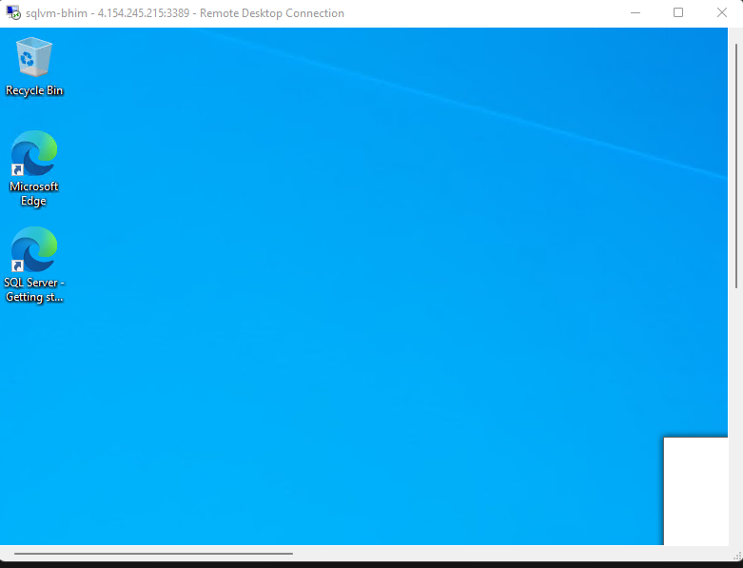

Go to Server manager – Local Server and disable IE Enhanced security Configuration. Otherwise it will ask for permission in browser again & again.
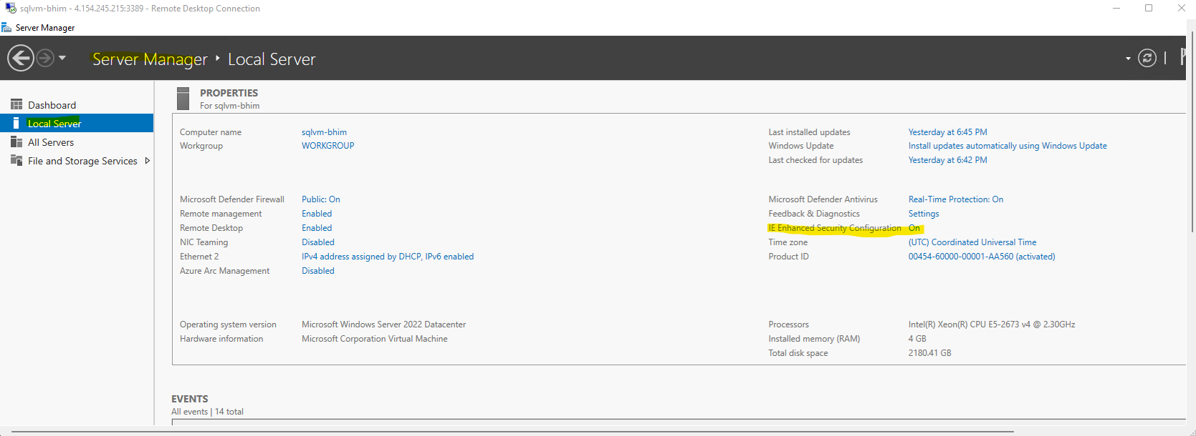

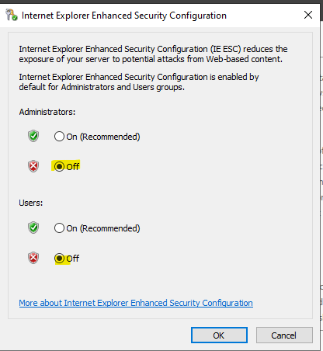
Go to edge browser and download the self hosted integration runtime on your VM and install it.

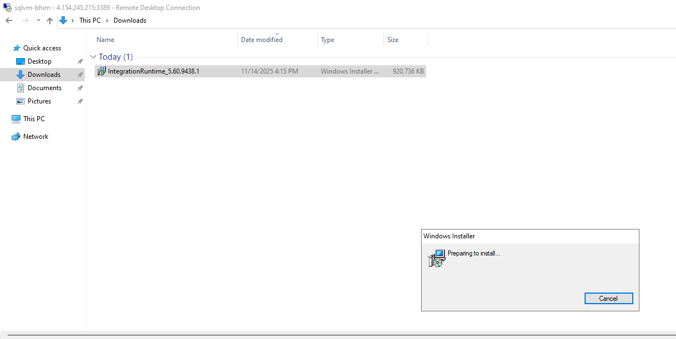

Side by side open aure synapse – go to manage tab – integration runtime – Create New - Azure self hosted integration runtime
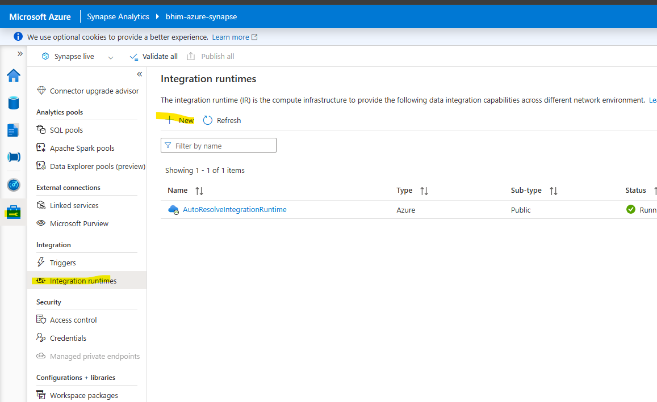
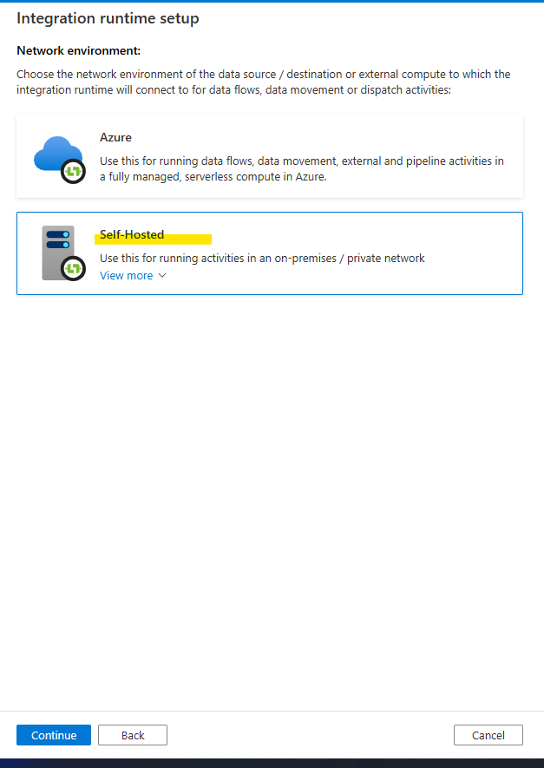
And copy any key
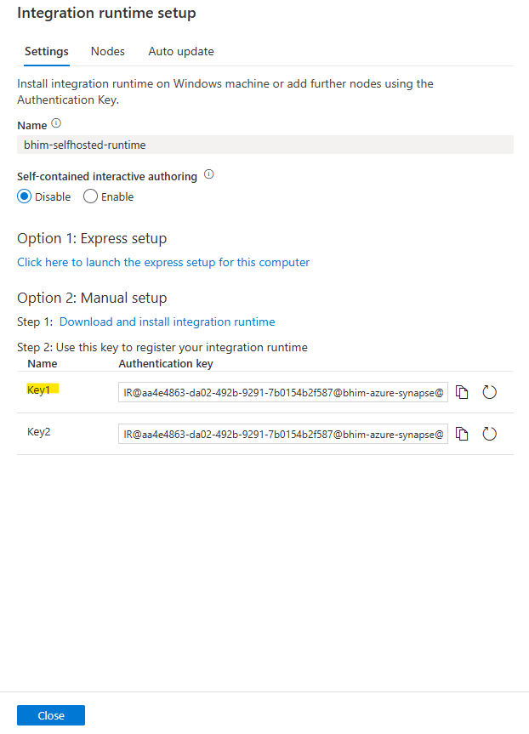
Copy key in the self hosted runtime dialog box in VM and register.
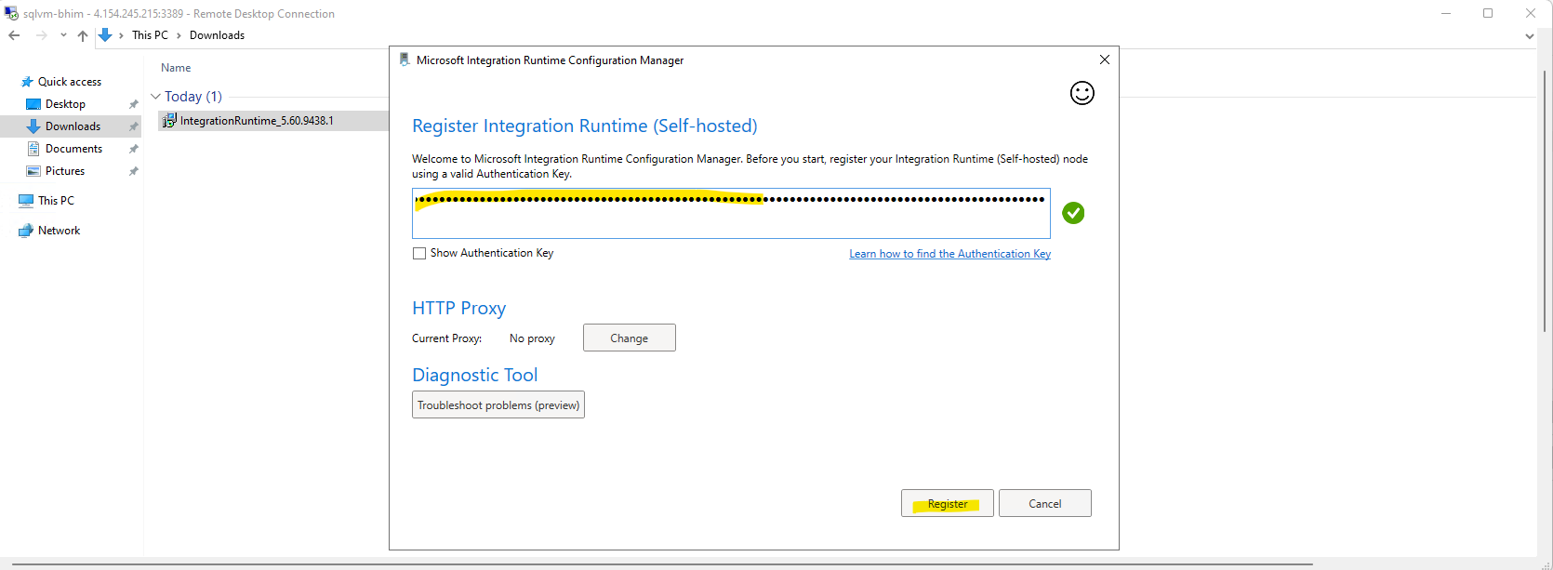
Finish it.
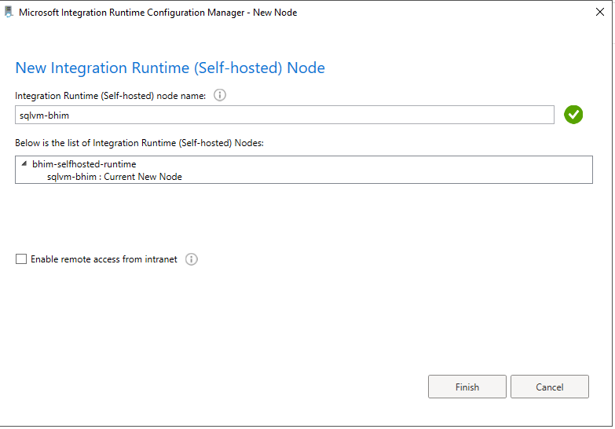

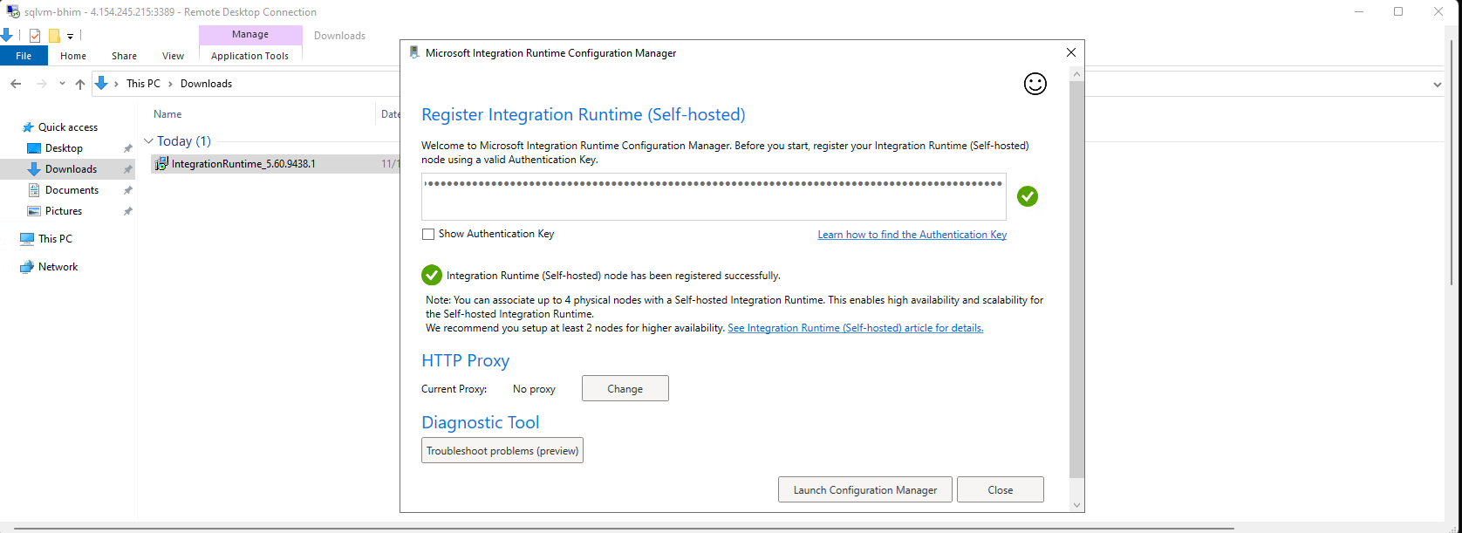
Open SSMS in your VM and select SQL Server authentication give the id and password same as your VM login credentials.
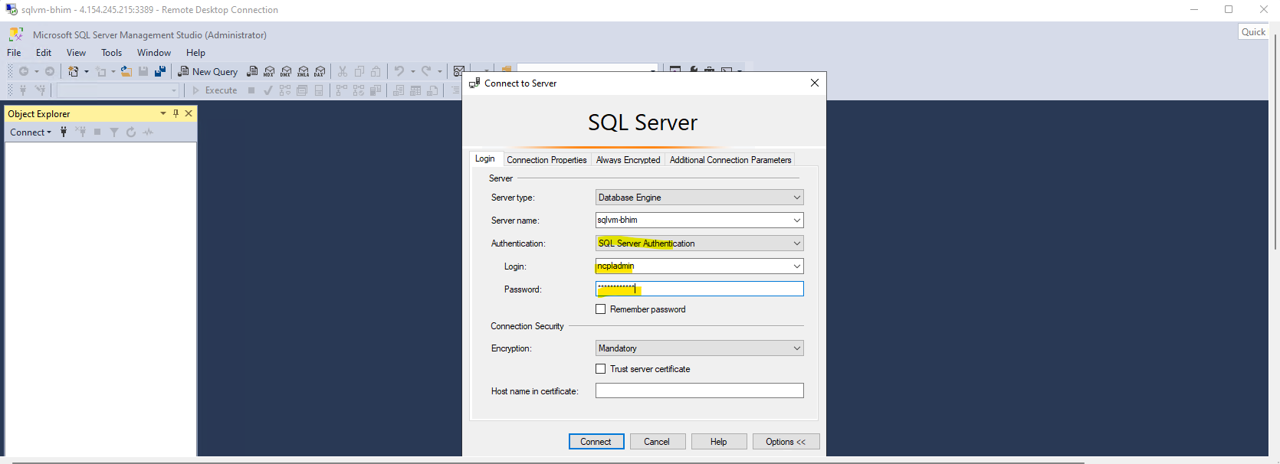
Create database.
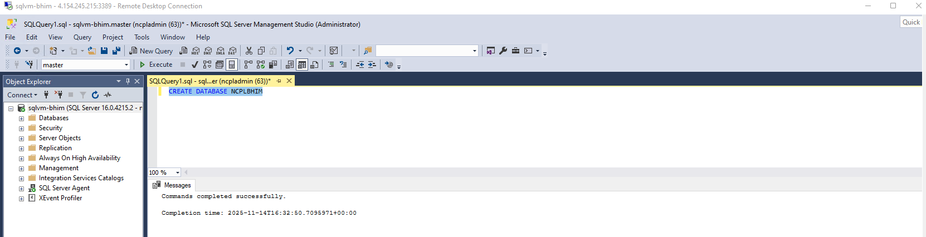
Select your database, create table and insert the data into that table.
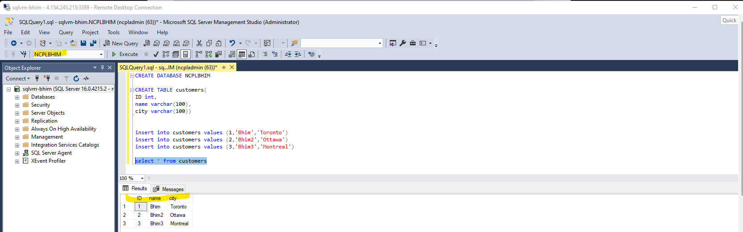

Go to synapse – create pipeline – select copy activity and set up the source side create new linked service.
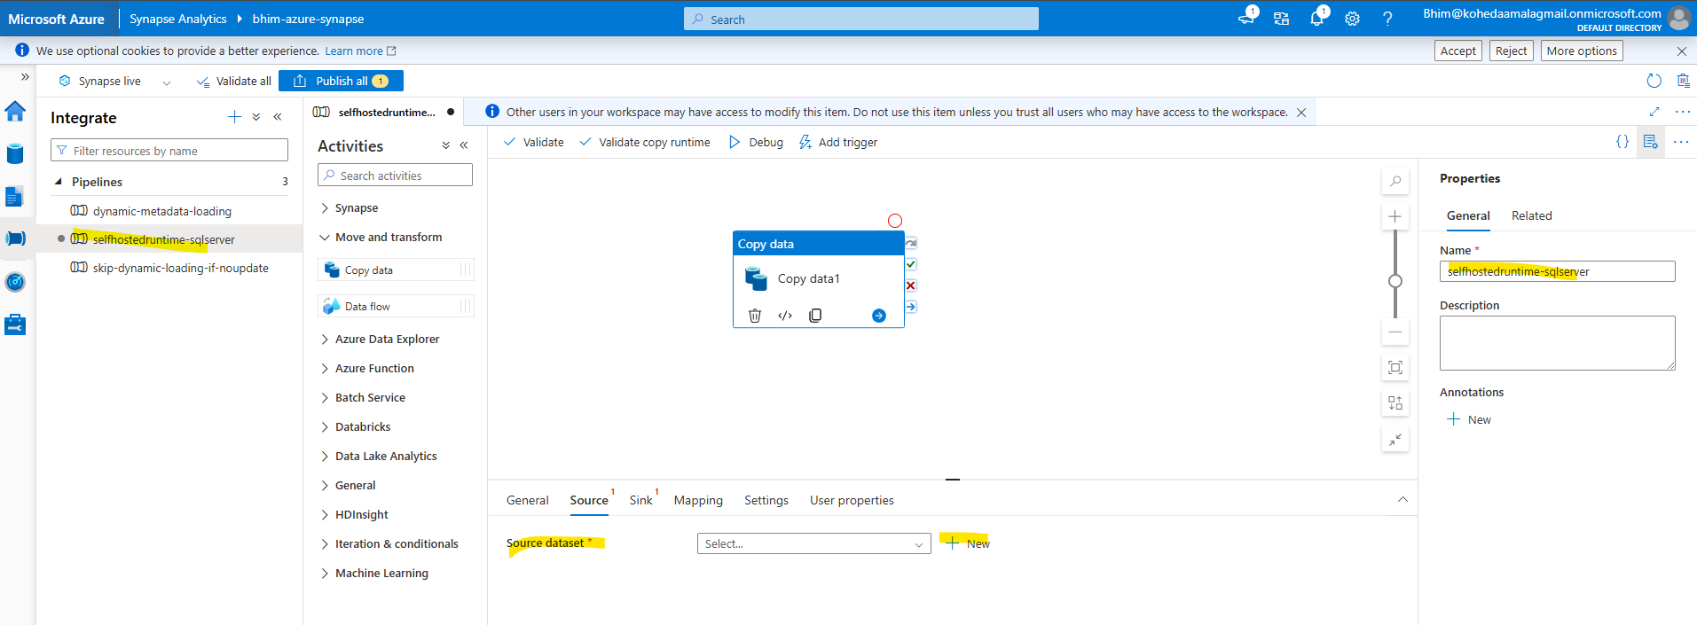

Select sql server.

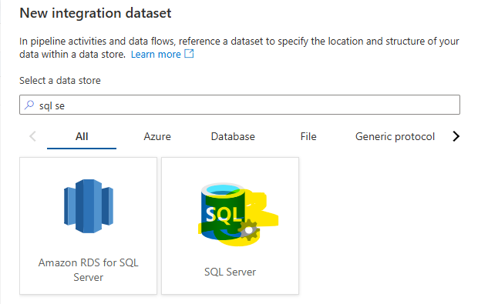
Create new linked service and change the integration runtime from autoresolve to self hosted. Give all the details id and password. Select optional encryption. Test connection.
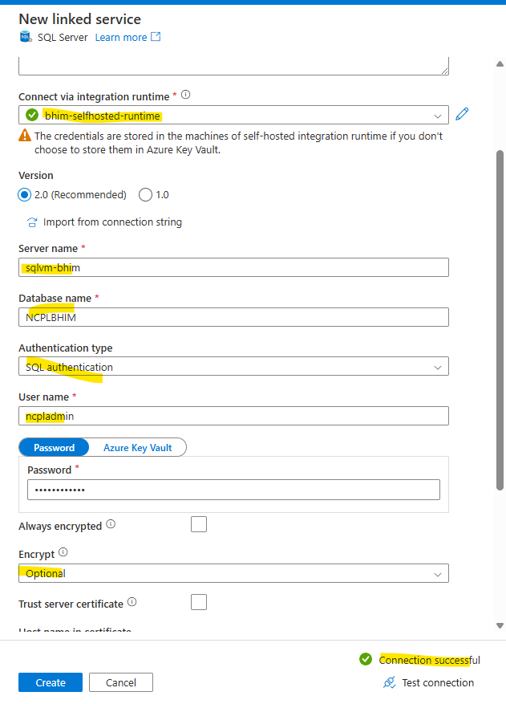
Select the table which we created on the VM machine SSMS.
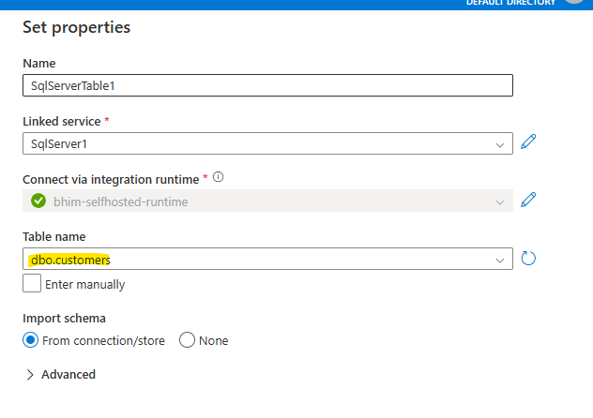
SSMS in VM –
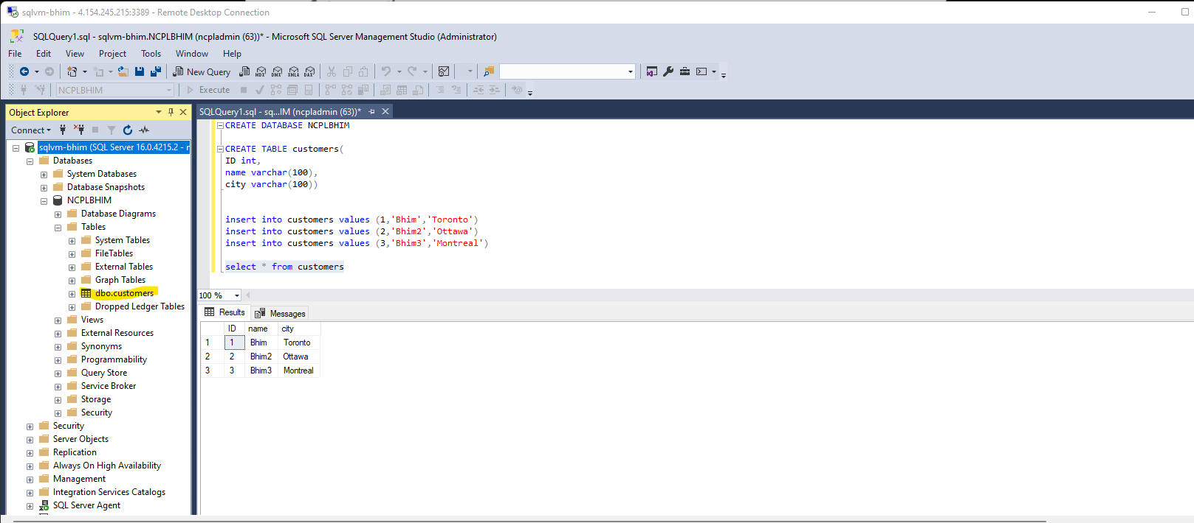

Now set up the sink side. Create linked service which will connect to the ADL Gen2 storage.
Select ADL Gen2 – Delimeter csv – select autoresolve integration runtime because now we are transferring data from cloud to cloud, but in case of source side the data is coming VM’s sql server which is on-premise device like instead of VM you can use your personal laptop and computer.
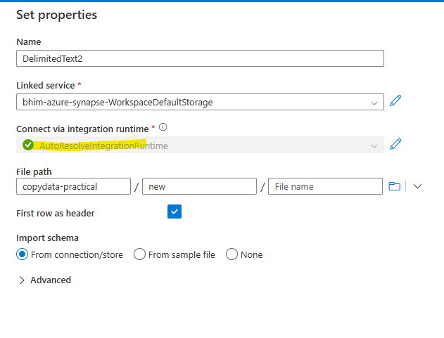
Change the file extension from .txt to .csv
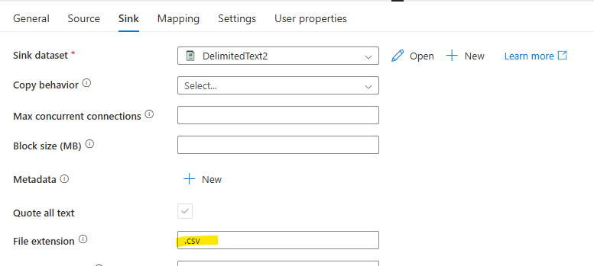

Run the pipeline.
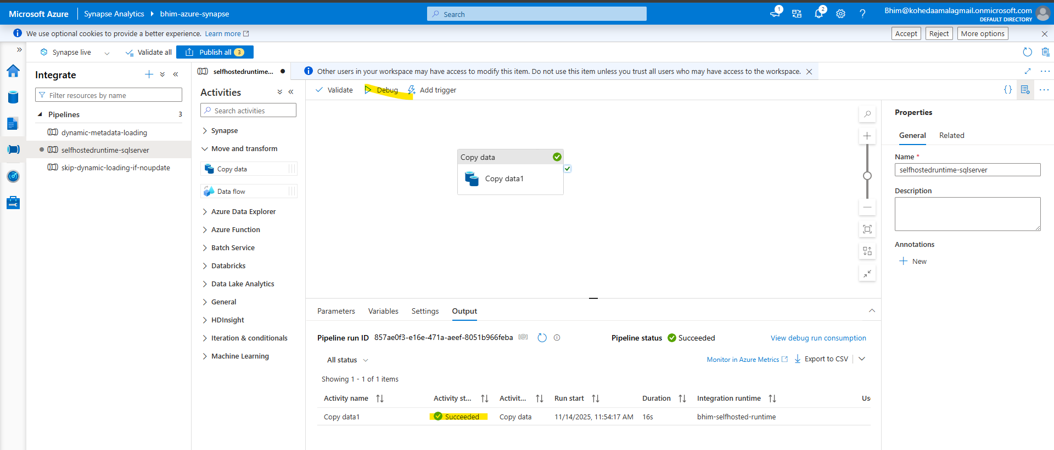
Check the ADL Gen2 storage. Successfully transferred the data from on-premise to cloud.
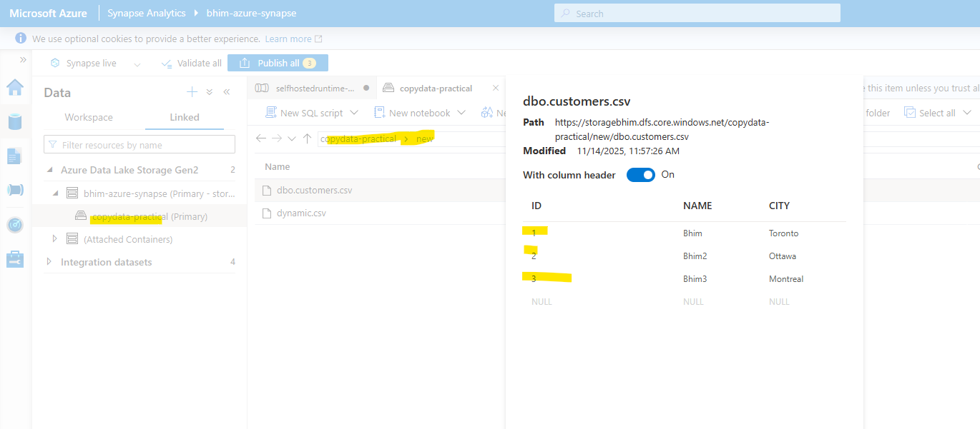

Move data from C/:drive to cloud.

First go to VM – C drive – create a csv file and add some data.
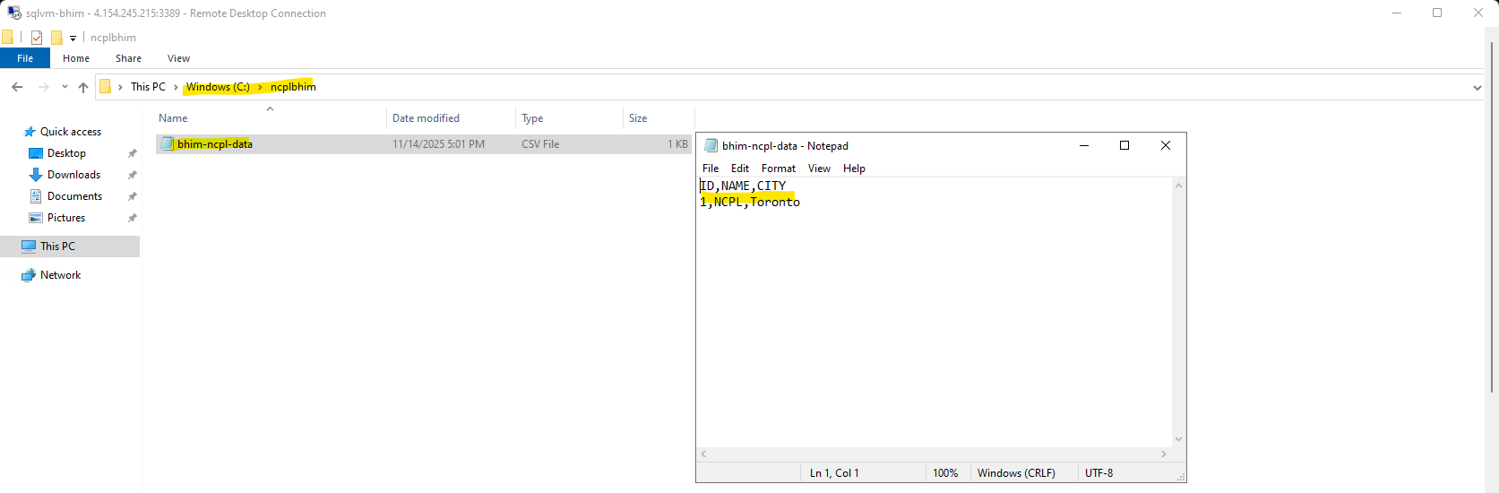
Go to Azure Synapse – Create new pipeline – select copy activity and set up the source. Select File system and select delimiter text.
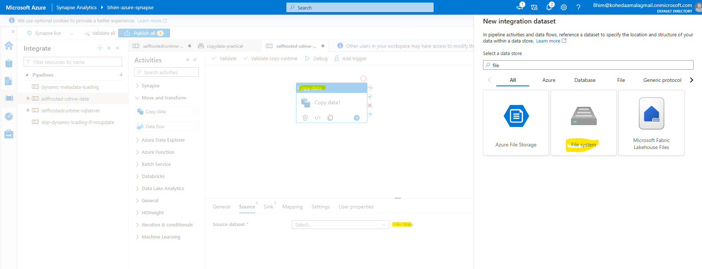

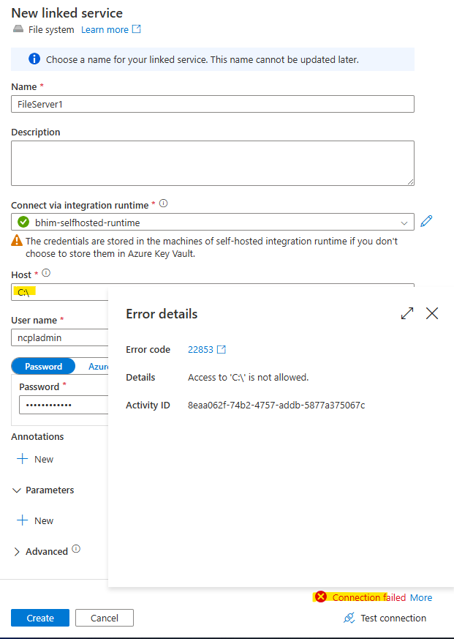
To resolve above issue. Go to your VM and go to below link –
https://stackoverflow.com/questions/76101174/access-denied-to-server-in-file-system-linked-service-in-data-factory

and run below commands in powershell one by one. Which you will find the above link.
.\dmgcmd.exe -EnableLocalMachineAccess
.\dmgcmd.exe -DisableLocalFolderPathValidation
.\dmgcmd.exe -DisableLocalFolderPathValidation
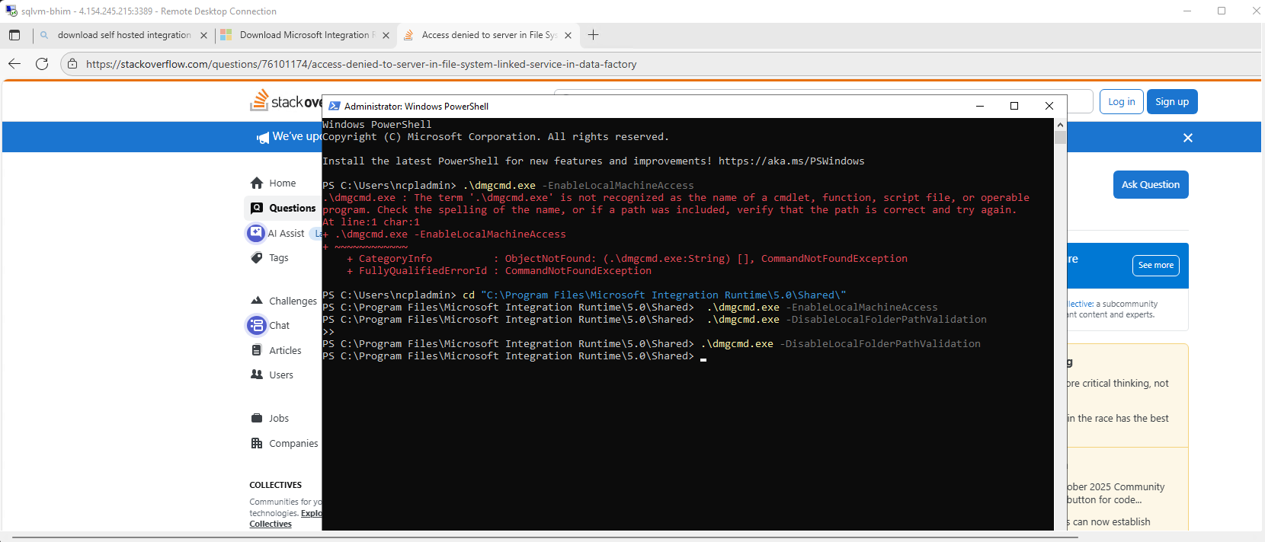

After running these commands successfully go to synapse and test connection again.
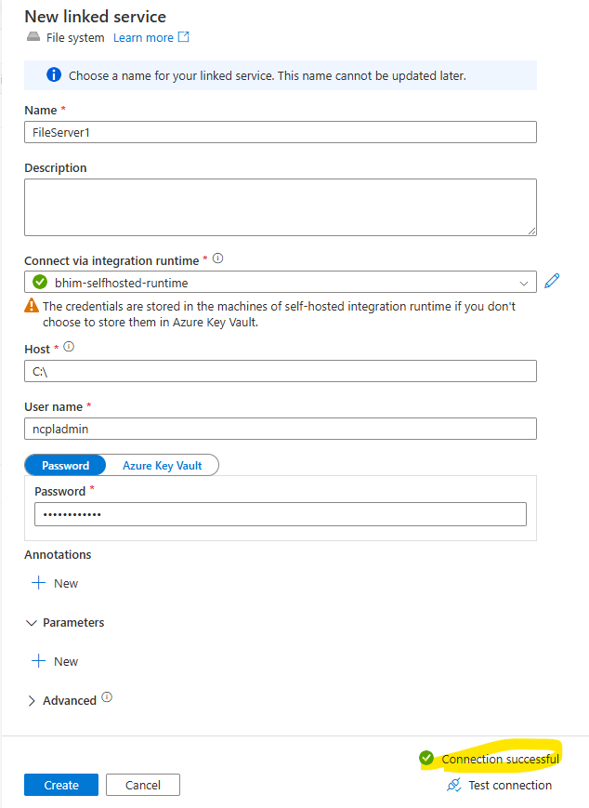

Select the path where our file is located in c drive in VM using clicking on folder icon.
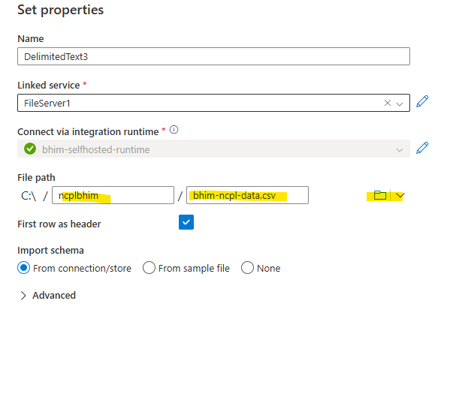

After that setup the sink side same as above which we configured previously. Run the pipeline.
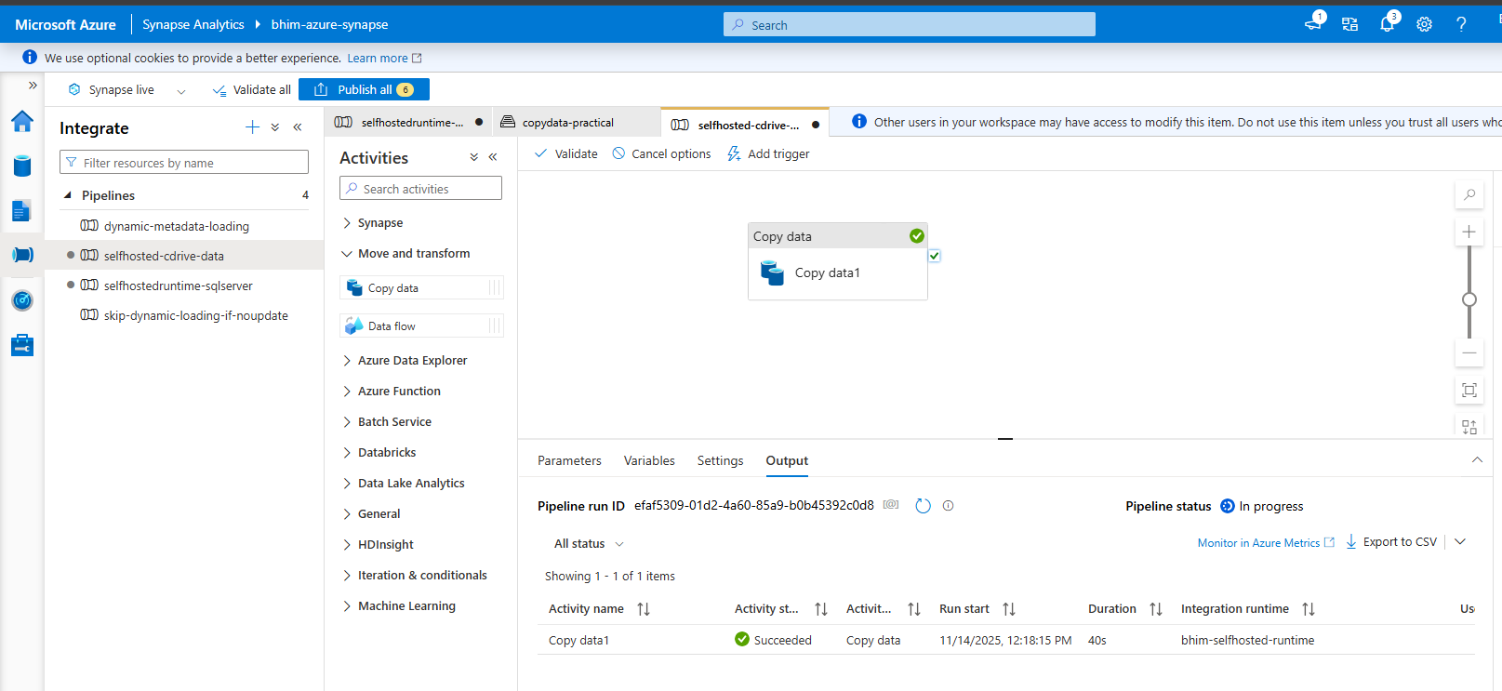
Successfully transferred the file data from drive of VM machine (on-premise) to cloud (ADL Gen2)
